**OOP’s Python Assignment**

**8th Feb. 2023**

**Q1. What is Abstraction in OOps? Explain with an example.**

**Sol. Abstraction in python** is defined as a process of handling complexity by hiding unnecessary information from the user. This is one of the coreconcepts of object-oriented programming (OOP) languages.

Example,

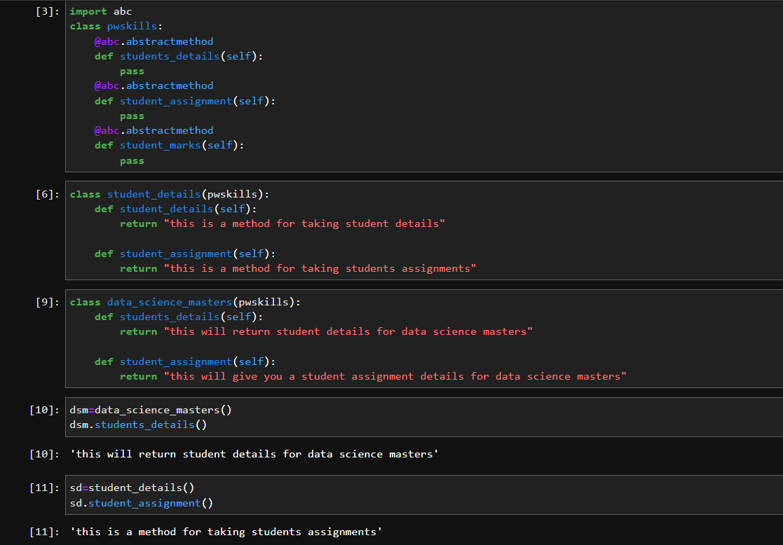

**Q2. Differentiate between Abstraction and Encapsulation. Explain with an example.**

**Sol.** Abstraction is a way of representing some specific data.

Encapsulation is a way of hiding the complexity of something and exposing only the parts you wish to expose.

Example of Abstraction,



Example of Encapsulation

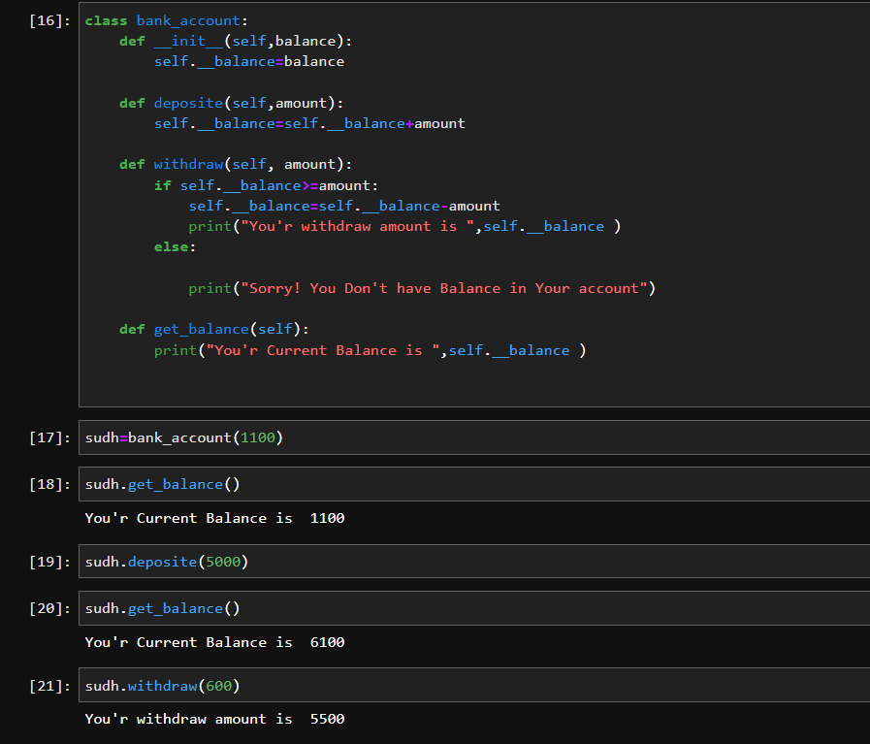

**Q3. What is abc module in python? Why is it used?**

**Sol.** The 'abc' module in Python library provides the infrastructure for defining custom abstract base classes.

'abc' works by marking methods of the base class as abstract. This is done by @absttractmethod decorator.

**Q4. How can we achieve data abstraction?**

**Sol.** abstraction can be achieved by having/using abstract classes and methods in our programs. **Understanding Abstract Methods and Classes:** An abstract method is a method that is declared, but does not contain implementation.

**Q5. Can we create an instance of an abstract class? Explain your answer.**

**Sol.** We cannot create an abstract class in Python directly. However, Python does provide a module that allows us to define abstract classes. The **module we can use to create an abstract class in Python is abc(abstract base class) module.**